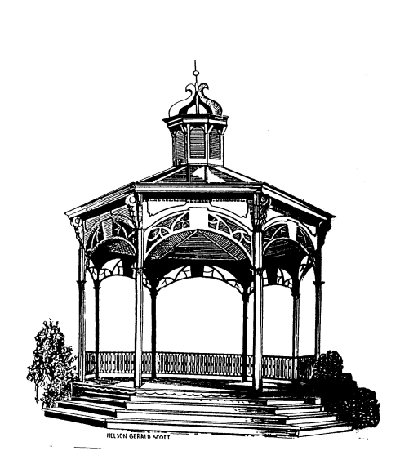
City of Fenton

NOTICE OF CANCELLATION

There being no public hearings or business pending before the City of Fenton Zoning Board of Appeals, the meeting scheduled for July 27, 2021 has been cancelled. The next meeting is scheduled for August 24, 2021.

Carl Hammond
Chairman

