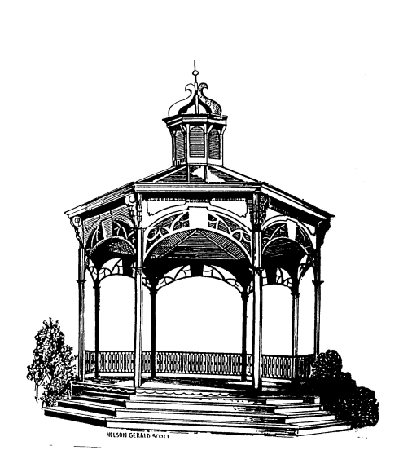
City of Fenton

NOTICE OF CANCELLATION

There being no public hearings or business pending before the City of Fenton Zoning Board of Appeals, the meeting scheduled for January 26, 2021 has been cancelled. The next meeting is scheduled for February 23, 2021.

Carl Hammond
Chairman

