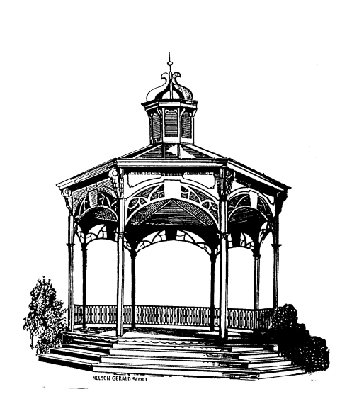
City of Fenton

NOTICE OF CANCELLATION

There being no public hearings or business pending before the City of Fenton Zoning Board of Appeals, the meeting scheduled for November 23, 2021 has been cancelled. The next meeting is scheduled for December 28, 2021.

Carl Hammond
Chairman

