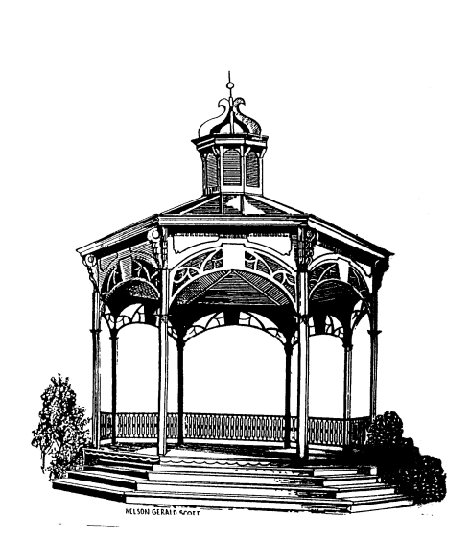
City of Fenton

NOTICE OF CANCELLATION

There being no public hearings or business pending before the City of Fenton Zoning Board of Appeals, the meeting scheduled for August 25, 2020 has been cancelled. The next meeting is scheduled for September 22, 2020.

Carl Hammond
Chairman

